User 2 —
Data Privacy and Login Trust
User Story
As a pet owner, I want to understand what personal data Pawtrace collects before I log in, so that I can decide whether I trust the app with my pet’s location and owner contact information.

User Activity
·The user was asked to check the login page.
·The user was asked whether they noticed any privacy or data collection explanation.
·The user was asked to explore the product functions using both Login Mode and Guest Mode within 2 minutes.
·The user was asked to describe the differences between Login Mode and Guest Mode.
·The user was asked which mode made them feel more comfortable and trustworthy.
User Validation Criteria
Metric | Target / Standard
Privacy notice entry | User can notice the Data & Privacy Agreement before full access.
Consent evidence | User can identify that full access requires explicit consent.
Guest Mode recognition | User can identify Guest Mode and explain its purpose.
Trust rating | User gives a trust score of at least 4 out of 5 after seeing the privacy information.
User Feedback
Before optimisation, User 2 hesitated at the login page because the app did not clearly explain what personal data would be collected. Since Pawtrace involves pet location, owner contact information, and safety monitoring, the user expected to see a privacy explanation before using the app fully.
This showed that users may not trust the product if the app asks for login or access before explaining how personal information will be used.
Quantitative evidence before optimization:
- Privacy notice entry: 0
- Consent completion: No explicit consent
- Privacy clarity rating: 1/5
Iteration Result
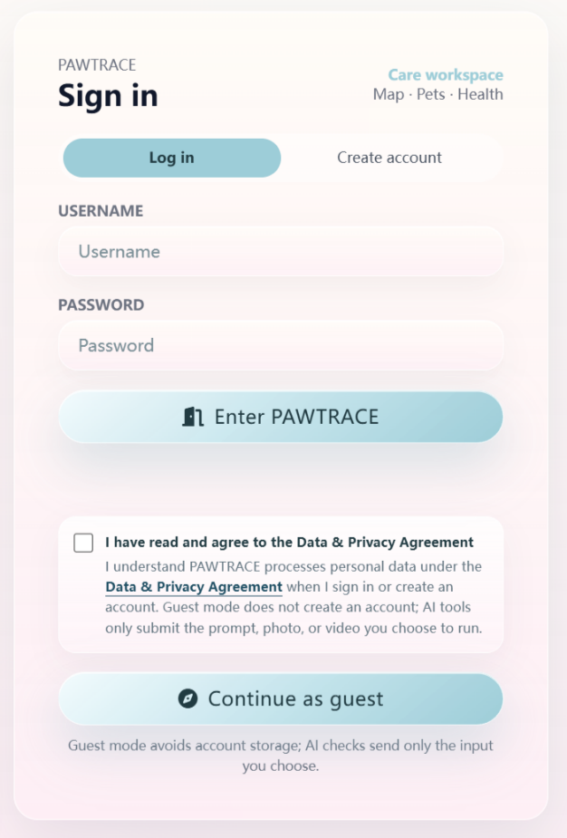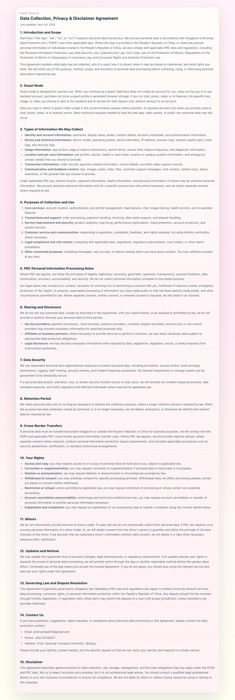
Key iteration: A Data & Privacy Agreement was added to the login page, and a consent checkbox was required before full access. A Guest Mode was also added for partial use without personal data collection.
After optimisation, the user could clearly see the privacy agreement before full access and understood that the app may involve location and contact-related data.
Quantitative evidence after optimization:
- Privacy notice entry: 1 Data & Privacy Agreement
- Consent completion: Checkbox required before full access
- Guest Mode: Available
- Privacy clarity rating: 5/5
This iteration improved trust and made the login flow more transparent.

